

(Enter Club Name)

# Volunteer Management Action Plan

(Enter Club Logo)

“Our club’s vision will be achieved through the dedication and contributions of our volunteers.”

# Volunteer Management Action Plan (VMAP)

**Follow the VMAP steps outlined for the club member size indicated below. Complete any sections in ‘red’ to personalise the VMAP for your club. Review your VMAP annually.**

**(remove this ‘Instruction’ section once completed).**

## *For (enter club name)*

## Expectation

To assume every club member will be ready to volunteer for the same kind of activity or to put in the same amount of time and effort would be unrealistic. However, it is not unrealistic to assume that every member of our club should devote some level of time and effort to supporting the club that they are part of. Finding a job/task/position for everyone should be the goal, or at the very least, getting everyone to commit to contributing in some way, e.g. at a minimum supporting peers and other volunteers.

Impactful volunteering begins with creating the appropriate culture.

When discussing volunteering, our club should use the phrase “this is the way we like to do things together here,” a commonly used statement. Members should be made aware at the time of joining, that the club is run mostly by volunteers, with some clubs having a small number of paid employees, so tasks, jobs, flight operations, and the value clubs offer would not exist without combined voluntary efforts and team support.

## Club Profile

Our club is a vibrant and active community gliding organisation committed to giving back to members and the community, enhancing confidence, skills, and well-being, and creating a sense of purpose. We have a wide variety of members, from those who want to spend time with like-minded individuals to those who want to learn new skills, like becoming a pilot. Our club could not function without the combined efforts of our volunteers.

It's critical to comprehend and encourage a culture where people believe that being a member entails giving, contributing, and committing in some way.

This will guarantee that the membership commitment is not just about a select group of seasoned volunteers, as all members will be expected to share volunteer efforts.

The value of volunteer involvement requires processes and systems to be implemented, i.e., to ensure a positive volunteer experience is a priority. Meeting this standard assists our club in providing a clear direction and guidance for the work of volunteers, as well as mitigating any barriers and risks related to volunteer involvement.

# VMAP Steps All Clubs: <50 members, 50 to 100 members, >100 members

# Step One: Make a Plan

**Summary**: A VMAP lets everyone know how they can help and what they are expected to do to assist volunteer engagement. Use the Volunteer Management Framework information to help you identify what volunteer roles are needed in your club, what type of person you need to fill them, and what roles require recruitment. Complete the VMAP to ensure everyone is clear on how they can help and what they are expected to do to create volunteer engagement.

Read the Volunteer Management Framework

Understand the EAST approach

Identify your club profile (number of members)

Our club profile is (small/medium/large) and we will ensure the following tasks are implemented in our club:

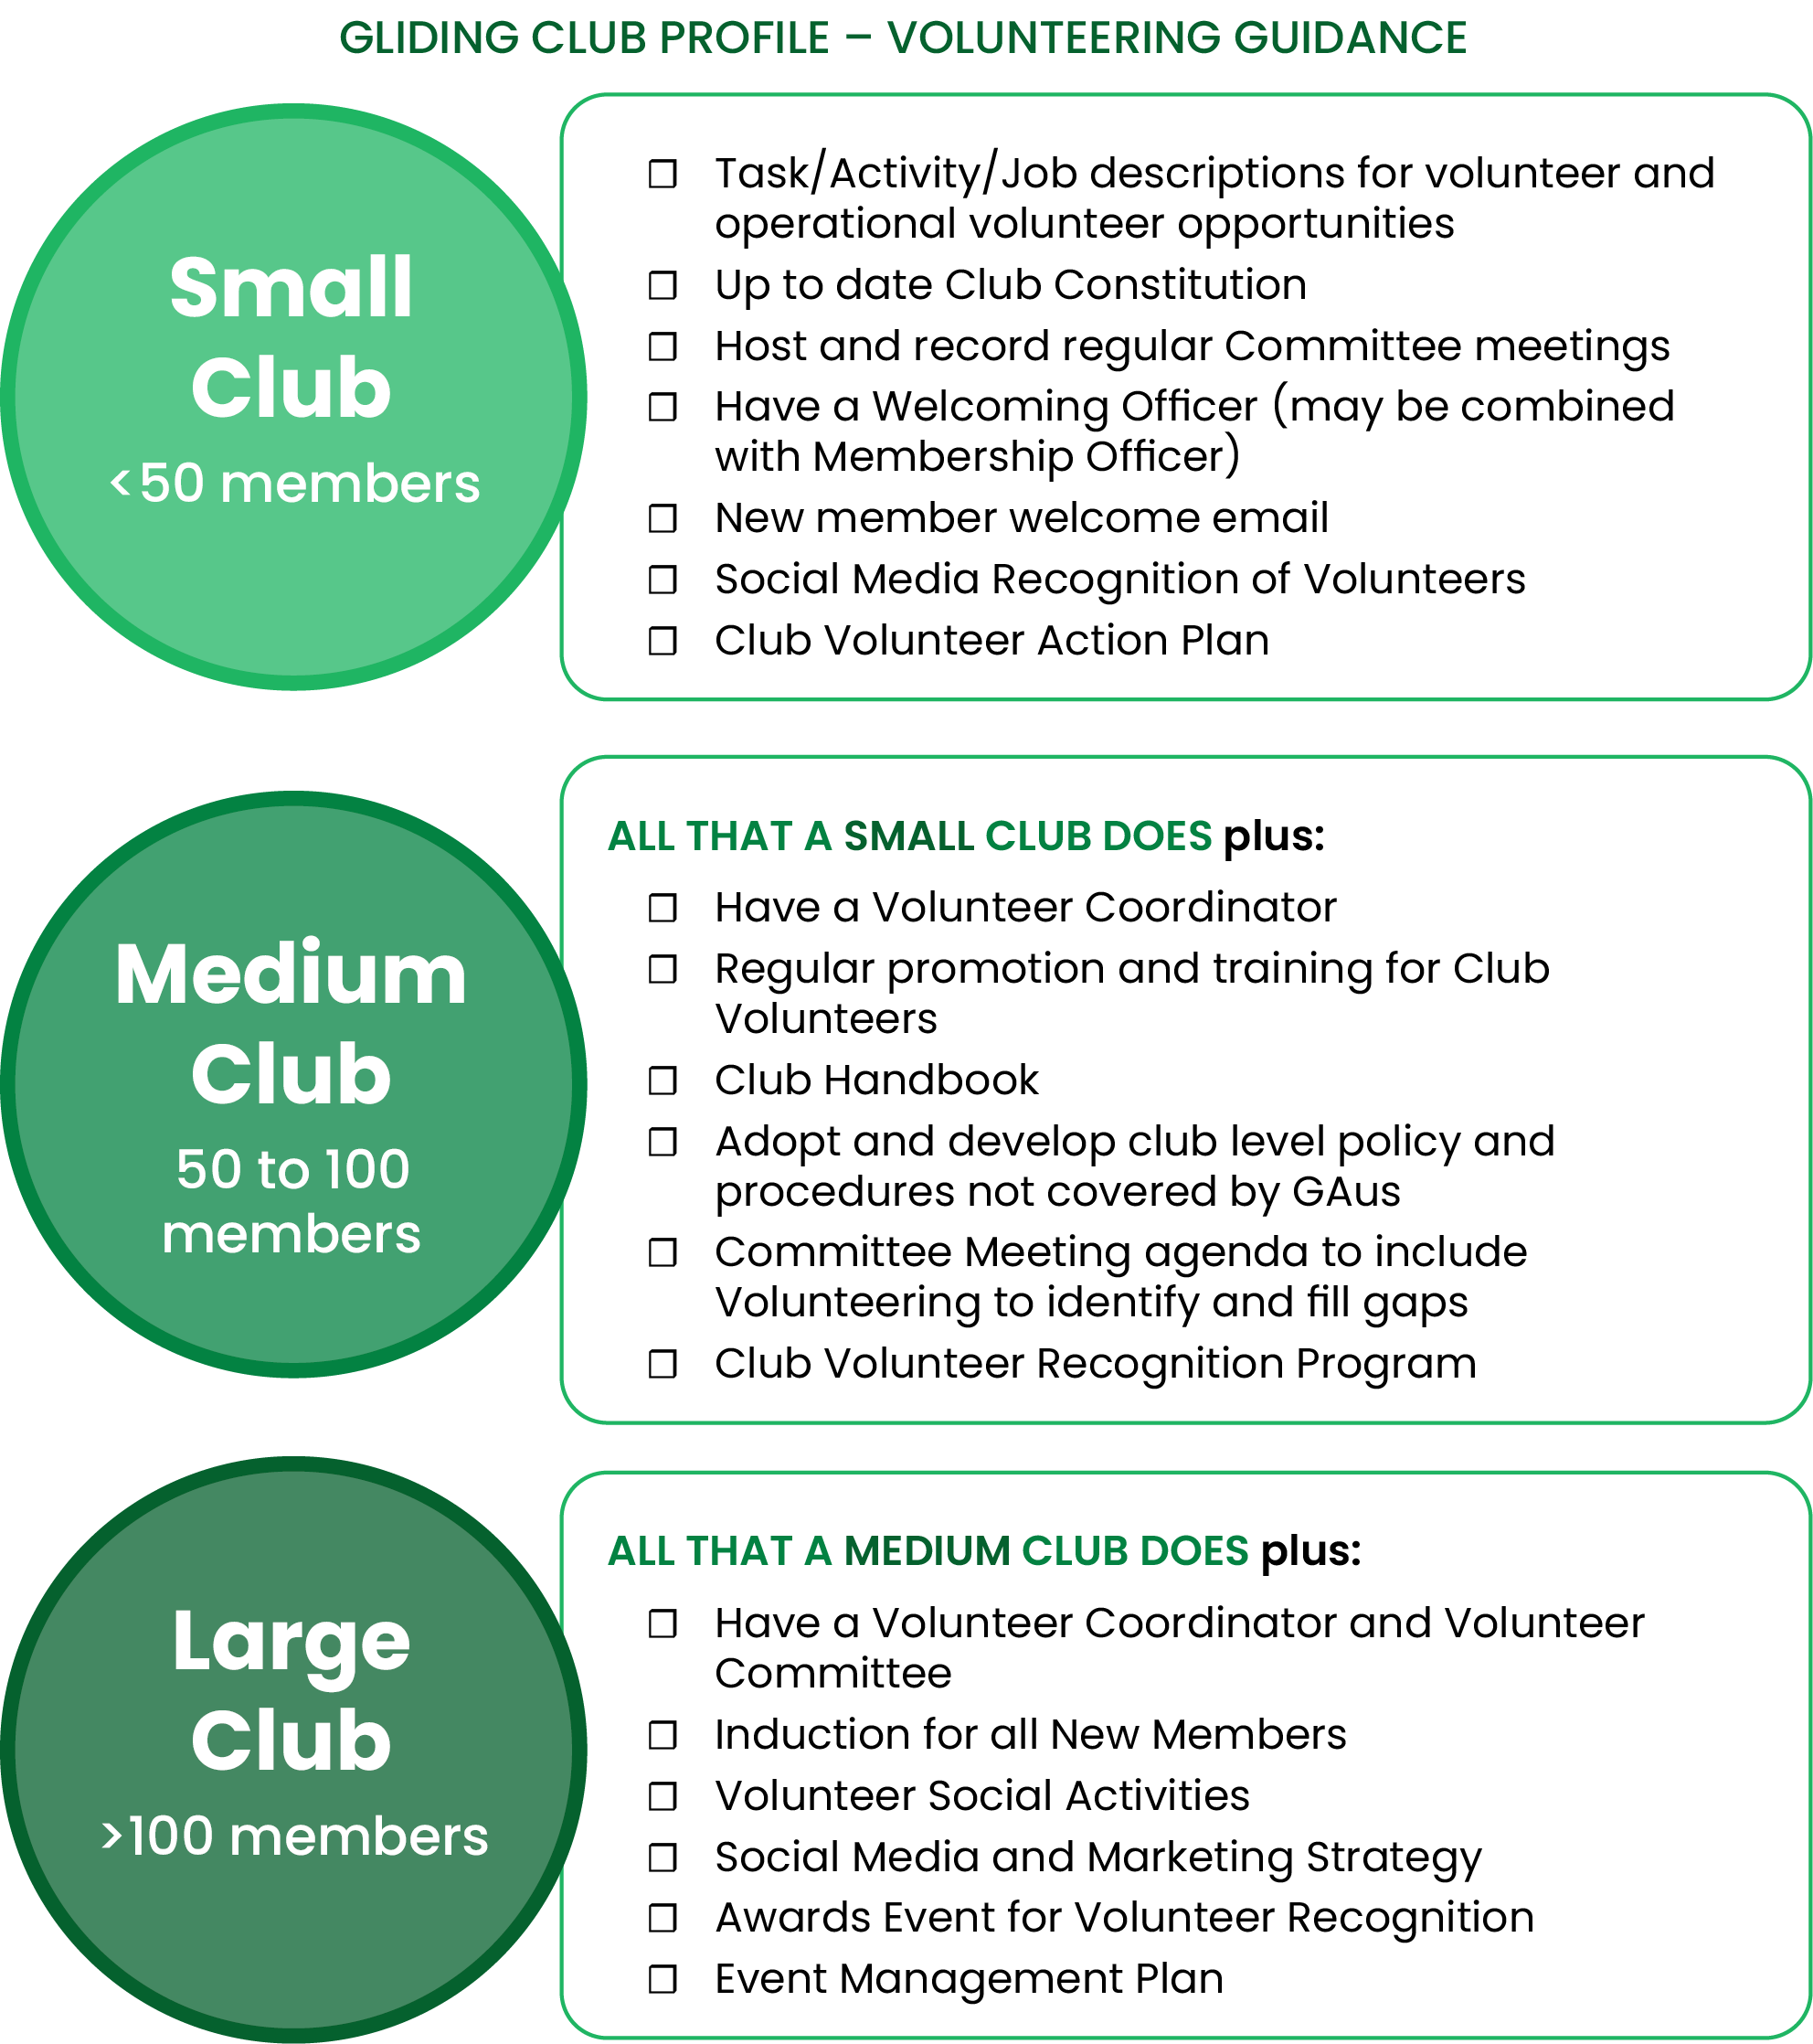

*We will consider recommendations from larger categories where available, as long as we have the necessary volunteer resources to implement them.*

Review the club development resources on the GAus Website – Clubhouse Menu Tab to support Volunteers in your club roles.

Review the Instructing, Coaching, and Airworthiness pathways on the GAus Website to support Operational Volunteers in your club roles.

## Step Two: Engage new and current volunteers

**Summary**: Identify essential volunteering roles in and out of the air, what skills they require, and then consider how best to engage these types of people. People volunteer for various reasons and fostering a sense of belonging and community strengthens connections, keeping both current and potential volunteers engaged and connected.

Make a ‘Volunteer’ and ‘Operational Volunteer’ list of specific roles and tasks (see Appendix A: Volunteers and Appendix B: Operational Volunteers templates).

* Add and remove any volunteer or operational volunteer roles to provide an accurate volunteering representation of your club
* Feel free to add specific volunteering tasks that may not be associated with any role (i.e., stocking the kitchen or bar items, garbage removal, clubhouse maintenance, bathroom cleaning, etc)
* Allocate Volunteer Hrs/Week expectations
* Identify Attractive/Social components of the role for advertising/discussions
* Identify formal and informal training requirements and length of training for roles.

### Example:

|  |  |  |  |  |
| --- | --- | --- | --- | --- |
| Welcoming Officer (or Membership Officer)  Limited formal training, contact can be done at club or from home, flexibility of hours and commitment.  Social and highly interactive with members in person and on the phone. | Welcome and induct new members and maintain a relationship. | 2-4hrs/wk (varies week to week). | GAus Integrity Training. | Internal recruitment – someone knowledgeable on club pathways. |

Look at each role/task separately (this can be done by key personnel), to determine potential barriers to the volunteer role:

* Time
* Training availability
* Confidence
* Availability to do role regularly (job share).

**Tip:** When creating separate tasks or smaller tasks that can be shared, it is recommended to still have one experienced volunteer as the overall coordinator to ensure tasks are completed (however, not having to do the tasks themselves).

Consider potential strategies to remove barriers for each role (this can be done by key personnel):

* Create smaller volunteering roles/tasks
* Remove some tasks as stand-alone roles
* Group training opportunities
* Mentoring (informal and formal)
* Consider making online roster options, where people can nominate days, for ongoing tasks in or outside of the club.

**Tip:** Consider using free technology such as [signup](https://signup.com/volunteer-scheduling) or [signupgenius](https://www.signupgenius.com/) to schedule volunteer timeslots, tasks, equipment, and reminders.

Create position descriptions or task descriptions for Volunteer and Operational Volunteer recruitment.

**Tip:** Don’t start from scratch, use the position description templates as a starting point (download and edit to suit your club's needs) from the [GAus Website – Clubhouse Tab](https://glidingaustralia.org/the-clubhouse-club-development/)

Identify potential internal candidates to speak with for each Volunteer and Operational Volunteer role that is vacant or will soon be vacant.

* Identify who is the best person to speak to a potential volunteer
* Identify what makes the volunteer role attractive
* Identify what makes the volunteer role social
* Identify how the role can be modified to address barriers.

Identify potential gliding community candidates who can assist short or long-term with Volunteer and Operational Volunteer roles. These may include:

* Bolstering instructor numbers with a roster of instructors from other nearby clubs
* One-off projects that external members can assist with
* Mentoring for minority groups or higher-level instructors.

Potential external recruitment options for Volunteer roles.

* Volunteer recruitment agencies (Seek Volunteer)
* Local Council notices, local libraries, community groups
* Local universities, TAFE, etc
* Former members of your club.

**Tip:** When recruiting outside of your club, ensure you make it **easy** for potential volunteers to contact the club to ask questions or speak to someone in a timely manner.

Advertise your volunteer roles

* Choose the right platform (this included face-to-face conversations)
* Know where you will advertise and any expectations the forum may have
* Adapt your content for the platform and audience selected
* Ensure you have contact details for potential volunteers to get quick easy information.

**Tip:** When creating a great advertisement:

* have an eye-catching headline;
* be concise;
* use a compelling image for social media;
* use straight-forward language (no jargon);
* describe the main tasks, hours, and skills needed;
* mention any qualification or checks required;
* highlight the importance and benefits of the role to volunteer;
* provide contact info and how to apply;
* use engaging phrases like “are you looking for…” rather than ‘volunteer’.



Appoint a Welcoming Officer to your club whose main role is to make new members, volunteers, and family feel welcome at your club. A personal touch with a conversation, phone call, or follow-up, goes a long way in having members and volunteers feel valued and included.

Create and implement a new member email that introduces volunteering expectations for your club and a point of contact for any questions they may have.

### Example:

|  |
| --- |
| Dear (name),  Firstly, WELCOME to (name of club), we’re genuinely excited to have you join us as a member.  As gliding offers countless opportunities for you to explore and enjoy, we’re here to introduce you to them and support your journey at your own pace.  Most of our members join the club to learn to pilot a glider, and we have highly valued instructors to assist in this space. Who knows, maybe down the track, you may also be interested in pursuing this additional training to help new members like yourself, learn the art of gliding.  Importantly, our club also relies on our members contributing (volunteering) in some shape or form (depending on your circumstances) to the daily running and administration of our club.Every volunteer contribution, no matter how small, makes a difference, and we truly value any support you can offer to help share the load.  For example - this includes coming out to the airfield earlier than your scheduled training to assist in preparing our gliders for the day's activities, retrieving gliders and running wing tips in between your training.  We also have opportunities in maintenance (formal training), instructing (formal training), committee positions, airfield and facilities support, small projects, and (include any other opportunities). Gliding is an amazing individual sport, made possible by teamwork on the ground, so please let us know how you can apply your skills and knowledge. Or, if you have limited time, we may have a small job that can be done remotely from home, for example.  Please expect my contact in coming weeks to see how you are settling into the club, and to answer any questions you may have. I’m also more than happy to help you find a volunteering role that matches your interests and works for you.  In the meantime, feel free to contact me at any time on (insert number).  (insert name)  Welcoming Officer /Membership Officer  (insert club name) |

# Step Three: Keep volunteers involved

**Summary**: Certain roles in gliding require specific skill sets and ongoing training to ensure the safety of our pilots and fleet. Inducting and upskilling for committees and other non-operational roles is also vital to ensure volunteers are comfortable with the work they need to do. Volunteers' personal lives change too, so it is important to check in, provide support, and offer feedback and assistance when needed. These little efforts ensure your volunteers feel valued and seen as a person and not just a club resource.

Create and propose a volunteer training/upskilling club budget for committee approval.

Once the club budget is approved advise key personnel of budget availability and approval process for training /upskilling Volunteers and Operational Volunteers.

When recruiting Volunteers and Operational Volunteers discuss clear expectations (by key personnel) for the volunteer role which may include operations and technical aspects, behaviours, deadlines, competitions, projects, training completion, integrity courses, Working With Children Cards, etc.

Discuss support opportunities to meet tasks or expectations including mentoring, group support/learnings (instructors, airworthiness), club training, or GAus training.

Create induction opportunities for the key volunteer positions in your club. This does not have to be done for every volunteer role but is necessary for key roles within the club. Inductions include formal handover of:

* Awareness of drives, document storage, and portals
* Passwords
* Club documents
* GAus documents
* Keys
* Mentors (informal and/or formal)
* Resources to support the role
* Training opportunities (online or face-to-face)

|  |
| --- |
| Example of an Operational Volunteer Handover/Induction **Role:** Assistant to Tugmaster / Winch Manger – Ropes and Launch Equipment  Induction to include:   * Awareness of Winch Manual / Aerotowing Manual requirements, correct configuration of ropes and fittings * Guided inspections of ropes and equipment by Tugmaster / Winch Manager * Training in splicing, test weak links and fittings * Access to spares cabinet, workbench, tools, storage reels * Budget information, club ropes and fittings, suppliers and spares * Safety brief by Tugmaster / Winch Manager / Safety Officer * Mentor – Tugmaster / Winch Manager (contact details) |

Review volunteering opportunities, e.g. working bees or ‘Come and Fly’ days, to identify where tasks can be scheduled online in advance for shorter time blocks, and where equipment or resources may be needed to support volunteers. This approach helps ensure the right number of volunteers are engaged, while also allowing friends to coordinate and volunteer together, enhancing the social experience.

**Tip:** When recruiting to committee positions, use the committee induction checklist (relevant to your state) downloadable and editable from the GAus Clubhouse.

Organise social media recognition of Volunteers and Operational Volunteers with the Communications (Social Media) Officer. Consider allocating tasks to volunteers to take and forward photos to the Communications Team.

Check-in… set in place regular check-ins by key personnel for the first three months and then extend the check-ins over greater periods of time throughout the year.



**Tip:** No matter how experienced your volunteers are, it is important to check in with them throughout the year to see how they are coping with workloads and expectations. Life changes and we cannot take for granted our volunteers will be there unconditionally forever.

# Step Four: Create value and reward

**Summary**: Volunteers bring energy to your club community and your club can in return enrich a volunteer's experience with personal growth, skill development, and acknowledgment of achievement. Recognising and celebrating volunteers is essential for your club to show that their contributions are valued.

Create a Volunteer Contact List, which identifies contact details, volunteer jobs/skills, training, rewards, and recognition.

Organise key personnel to schedule annual reviews with your volunteers to identify personal growth and training they can enrol in and/or attend. This includes encouraging volunteers to move outside their comfort zone if it is appropriate to progress them through GAus pathways.

 Use annual reviews to gain valuable feedback from volunteers on how improvements and support can be considered. Where possible organise formal club feedback platforms to be accessed at any time by members and volunteers.

**Tip:** Offer help, not criticism. Expand support when plans or timelines are not being met. Share problems, build mutual respect, and make volunteers feel valued. forever.

Create a Volunteer Referral Program to reward member-recruited Volunteers and Operational Volunteers.

**Tip:** Feedback suggestions include thoughts on the role, workload views, suggestions for improvements, equipment or facility concerns, conflicts, support, success stories, future involvement, and potential successors.

Organise the creation of volunteer profiles to use in social media, newsletter communications, and general awareness among members.

**Tip:** Use videos to acknowledge your volunteers on social media. This allows opportunities for volunteers to be relatable and tell your community why they volunteer and ask members to join in volunteering at the club.

Create monthly volunteer recognition awards with the Communications (Social Media) Officer. Introduce these awards into the social media calendar and create reminders to award your volunteers. Even better, allow members to nominate volunteers who have made an impact in the club for that month.



**Tip:** Allocate a budget for vouchers from local bakeries and coffee shops in your town that can be awarded to your monthly volunteers. Alternatively, provide flight or membership credits when achieving in excess of 100 hours of volunteering.

Schedule volunteer social events throughout the year for all or specific areas of volunteering. These can be organised at the club or in metropolitan areas to create recognition and acknowledgment of volunteer groups. The more volunteers feel a sense of belonging the more they contribute, and a social setting is a good way of introducing potential volunteers to the club and creating the initial connection.



**Tip:** Encourage peer group involvement in volunteer social opportunities. Social engagement and social recognition create a sense of belonging, membership, respect, and inclusion.

# Step Five: Plan for succession

**Summary**: Succession planning helps clubs plan for the day a volunteer decides to hang up their wings and pass their role onto someone new. Anticipating this change and preparing new volunteers will assist your club in preparing for a future when key volunteers step down. Succession planning gives your club the best opportunity to have trained volunteers ready to step into key roles within the club.

Review your volunteer roles and see how tasks can be allocated to other volunteers as this is the first step in creating succession within your club.

Consider volunteers to identify potential assistants for roles or short-term projects that allow volunteers to see if they enjoy the roles.

Take the time to talk with people to ascertain their interests within the club or gliding in general. Just because you are aware of the pathways and options to contribute does not mean every member is. Don’t ever assume.

Encourage specific peer groups to support volunteers – they may help grow successors in their volunteering area.



**Tip:** Do not wait until you need volunteers… work ahead of time. Some volunteering roles take time to train individuals to a level where they are independent, while some people need to take time to commit to volunteering. Plant the volunteering seed and watch it grow with constant support, reminders, and encouragement.

Once you have volunteers in pathways, you need to encourage them to progress to the next levels. For example, AEF instructors may need some encouragement and belief that they can learn the next level of instructing especially if you offer some mentorship and individual support.

## VMAP Steps Medium Club 50 to 100 members and Large Club >100 members

**Recruit and implement a Volunteer Coordinator in your club.** Use the position description on the GAus website ‘Clubhouse Tab’ as a starting point.

**Tip:** Select someone from your club who is friendly, good at talking to people, organised, well-liked, and a problem solver.

Include a ‘Volunteer’ agenda item on **all** management committee meeting agendas. This will enable the Welcoming Officer, Volunteer Coordinator, and/or Volunteer Committee to update the management committee on all things volunteering. This includes, volunteering numbers, identified shortfalls, new volunteers, volunteering awards, volunteering opportunities, and small and long-term projects that might be looking for volunteering assistance.

Create a formal Volunteer Recognition Program (this can be a separate volunteer job, or several jobs depending on the volunteering component). This program will formalise items such as:

* volunteering identification (shortfalls, etc)
* volunteer marketing
* volunteer recognition/awards
* volunteer on social media platforms
* volunteer photographs and videos
* volunteer social events
* volunteer nominations
* reporting to the management committee.

Schedule Volunteer Training opportunities on the Club Calendar for all members to see. This may bring volunteering opportunities awareness to members who are new or unfamiliar with volunteering roles.

Create a ‘Volunteer’ section in your club handbook that identifies the need and requirement of some form of volunteering, no matter how small or large, by all members.

|  |
| --- |
| Handbook Example:VOLUNTEERING As we mentioned, we cannot run our club without your help….  We are aware that everyone’s circumstances are different with work, family, and competing activities/sports in today’s world. We do not want to add extra stress to busy lives, but we want you to know that your support of our club is always very appreciated. We hope to create a friendly, well-run, and secure environment for our members and their families. To achieve this, we offer a variety of roles, jobs, activities, and tasks that fit into your schedule.  We welcome any help, regardless of how often or the size of the task, and we are confident we can find something that matches your time and skills. Many hands make light work in running our club so please contact (add name and contact details or list some of the contacts for different volunteering spaces in your club) to express your interest and availability. Working With Children Checks To be a volunteer within our sport, or any sport, you **MUST** have a Working with Children Check approved, in your State or Territory, if you are likely to come into contact with children. Good news is, as a volunteer, it is **FREE** to apply.  In most cases we need you to get this card before you start volunteering, so it’s a great idea to get in early and then let us know your card details when you receive it. Just search “Working with Children Card in (enter state)” and our state application portal should become available.  Don’t forget to let us know you are interested in assisting us, even before you get your card. We want to make volunteering as easy as possible for you, so this way we can start getting you ready with any information that can help you upskill or transition into a volunteering role for our club. Committee As mentioned, our club is run by volunteers, both in and out of the sky. Legally our club must be run by a management committee/committee/board to comply with our club rules. To help make this easier we have a committee induction kit and access to some webinar training available. This can be done at your convenience, to assist people in understanding the roles and responsibilities of a Committee Member or to learn new skills you may be interested in.  Even if you do not believe you have time to take on a complete role but have an interest in other areas of the club like social media, fundraising, grants, facility development, etc - please let us know. We can always see what tasks we may have on hand or that are upcoming as your help would be greatly appreciated. If this space interests you, please contact (insert name and email/number). Trainers/Instructors Our trainers and instructors are highly valued in the club and in all honestly gliding would not exist without the tuition they provide for new students and upskilling our members. We know this is not something you can do straight away but we would love to put it on your radar in the future. The first step of instructing is getting accredited to provide Air Experience Instruction/Flights and you can do this if you are over 16 years old and have completed 50 hours of flight time and 100 launches as a Pilot in Command.  To learn more about becoming an Instructor/Trainer, chat with the club's Chief Flying Instructor (CFI), who can give you more information about the Trainers pathway in gliding. Other roles If we have not mentioned a role that may interest you or you have some expertise in certain areas that may assist the club, we want to hear from you. Please contact (insert name and email/number) so we can arrange a time to chat. We’d love to hear from you about how you might be able to make our club an even better place to be part of. |

# VMAP Steps Large Club > 100 members

Recruit and implement a Volunteer Committee in your club. This sub-committee shares the responsibility of a Volunteer Coordinator and for further developing the Volunteer Recognition Program.

 Introduce New Member Nights where new members (and current members) can find out more about your club and volunteering opportunities in a relaxed less formal atmosphere. Allow new members to ask questions and socialise with members of similar knowledge and experience to form social bonds within the club. Be mindful not to use jargon that can sound intimidating to new members as this can create a barrier to volunteering.

**Tip:** Invite current volunteers to speak at New Member Nights to tell their story on how volunteering helped them integrate into the club, make new friends, and assist with their gliding journey.

**Tip:** Make sure the Volunteer Committee has what it needs. This includes a budget, a regular agenda item, planning sessions, tools such as communication apps, and scheduling information.

Introduce an annual volunteering award in your club, or if you already have one consider naming it after a long-term volunteer who contributed greatly to your club. Building from your monthly awards, anyone nominated for a monthly award is in the running for the annual award. Alternatively, you can have a nomination process with clear criteria for members to nominate fellow volunteers.

Nominate volunteers for the Regional Association and/or GAus Volunteer Award.

Hand over full responsibility including ongoing updates and amendments to the VMAP to your Volunteer Committee.

# Appendix A: Volunteer Roles

|  |  |  |  |  |
| --- | --- | --- | --- | --- |
| Volunteer | Description | Volunteer Hrs/Week | Training/ Induction | Recruitment |
| President | Leadership |  |  |  |
| Vice President | Leadership |  |  |  |
| Secretary/Public Officer | Leadership/ Administrative Support |  |  |  |
| Treasurer | Leadership/ Financial Administration |  |  |  |
| General Committee Member | Leadership/ Portfolio Management |  |  |  |
| Member Protection Information Officer/ Child Safety Officer | Member Protection/Child Safety |  |  |  |
| Welcoming Officer/ Membership Officer | Welcome and induct new members |  |  |  |
| Volunteer Coordinator | Support volunteers, assist in recruiting and recognition |  |  |  |
| Communications | Club communication (newsletter) administration |  |  |  |
| (add in specific comms roles) |  |  |  |  |
| Website | Club website administration |  |  |  |
| Fundraising | Fundraising events and administration |  |  |  |
| Grants | Seek and apply for grants |  |  |  |
| Awards/ Presentations | Club nominations and awards |  |  |  |
| Ground Maintenance | Mowing, whipper snipping |  |  |  |
| Clubhouse Support / Social Events | Clubhouse and events coordination, catering, support |  |  |  |
| (add in roles) |  |  |  |  |
|  |  |  |  |  |
|  |  |  |  |  |
|  |  |  |  |  |
|  |  |  |  |  |
|  |  |  |  |  |

# Appendix B: Operational Volunteer Roles

|  |  |  |  |  |
| --- | --- | --- | --- | --- |
| Operational Volunteer | Description | Volunteer Hrs/Week | Training/ Induction | Recruitment |
| Chief Flying Instructor/Panel Chair | Operations safety, standards, training progression, oversight, panel chair |  |  |  |
| Deputy Chief Flying Instructor | Deputy, assisting in operations oversight |  |  |  |
| Duty Instructor | Operations oversight, safety, supervision of operations and training on any flying day |  |  |  |
| Airworthiness Officer | Club maintenance oversight and coordination, management of club glider Form 2s and AW issues |  |  |  |
| Tugmaster  (Aerotow clubs) | Towplane operations safety and standards, tug AW coordination |  |  |  |
| Winch Manager (Winch clubs) | Winch operations safety and standards, winch upkeep coordination |  |  |  |
| Airfield Manager | Upkeep of runways and operations area, land care, safety, and airfield facilities |  |  |  |
| Chief Duty Pilot | Duty pilot coordination and training, safety, and standards |  |  |  |
| Instructor/Tug/Duty Pilot Rosters | Roster coordination, day organisation responsibilities |  |  |  |
| Coaches | Performance flying coaching and event management |  |  |  |
| Club Safety Manager | Independent review of club safety standards, hazards, risks, advice to Panel Chair / CFI / Club President |  |  |  |
| Form 2 Inspectors/ Replacement of Components Officers | Annual glider maintenance inspections, ongoing AW support, assisted by ROCs |  |  |  |
| Level 3 Instructors | Instructor training and audit support, mentoring |  |  |  |
| Competition/ Camp Directors | Oversight and safety of comps, regattas, events, camps |  |  |  |
| (add in roles) |  |  |  |  |
|  |  |  |  |  |
|  |  |  |  |  |
|  |  |  |  |  |