Child Safety
Our club has a zero-tolerance policy around young people's abuse and neglect in any form. We are committed to keeping children and young people safe in and out of the sky. So, we need your help to do this!

As a valued member of our gliding community, you play a crucial role in protecting young people in our sport. Legally, you MUST know what you should do if you come across, suspect, or feel uncomfortable with a situation a young person may be in or may become involved in. This includes:
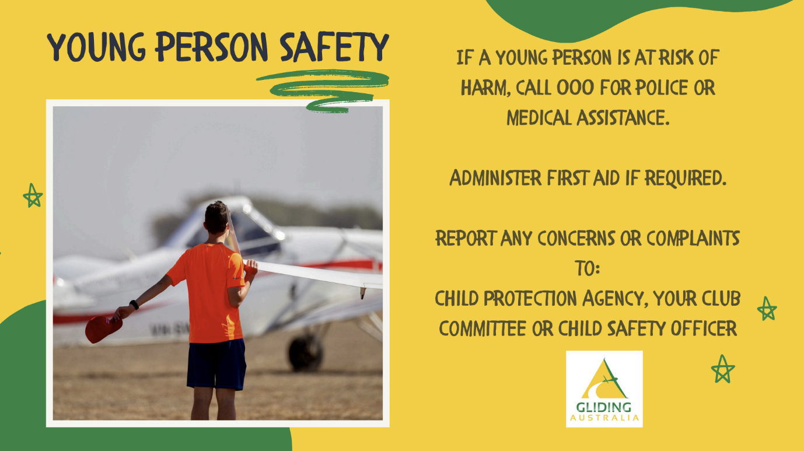

A more detailed policy in dealing with children can be found on the GA Website or you can contact our club Member Protection Information Officer/Child Safety Contact on the following (insert club details).

Finally, because we want our club to be young people safe, we want you to read through the safe and unsafe behaviours in gliding.

(insert final poster)

