`

**TYPE CLUB NAME HERE**

**And add club picture/image/logo**

Contents

WELCOME 3

OUR CLUB 4

WHERE TO GO AND WHAT TO DO THE FIRST TIME AT THE CLUB 5

OUR AIRFIELD 5

Aerodrome Access 6

Airfield Access 6

Parking 6

Flying Days 6

Club Days 6

OUR CLUB FACILITIES 7

Clubrooms / Clubhouse 7

Noticeboard 7

Food/Meals 7

Snacks 7

Alcohol 8

Toilet Amenities 8

Animals 8

Underage Driving 9

Facility Map 9

Communication 10

Communication Platforms 10

VOLUNTEERING 11

Working With Children Checks 12

Committee 12

Trainers/Instructors 12

Other roles 12

WHAT TO EXPECT IN GLIDING 13

Pilot Training 13

Manual of Standard Procedures (MOSP) 13

Pilot Logbooks 14

Daily Briefings 14

Appropriate Clothing 14

EVENTS 15

Club Championship Trophies/Awards 15

Social 15

State and National Events 15

INTEGRITY 16

Safeguarding Young People 16

# WELCOME

Hello!

On behalf of the (insert club name) (insert club abbreviation i.e. ABC), I want to give you a warm welcome. We’re excited to have you join our Club and look forward to your ongoing involvement.

Whether you are a beginner, an experienced glider, or looking to advance your skills, we are here to support you on your gliding journey. Our Club caters to all types of gliding enthusiasts, from beginners to cross-country pilots and everyone in between.

Our Club will provide access to flying activities, trainers, fleet and equipment, and a great community of fellow gliders. We can't wait to see you enjoy your gliding experience with us.

As a member of (insert club abbreviation), we encourage you to explore all the different aspects of the sport, including flying, training, airworthiness, and volunteering. We offer flying operations, training courses, club days, and state and national events to help you on your gliding journey. We know you'll find your gliding niche within our Club.

The (insert club abbreviation) is a handy guide that gives you an overview of the club and some general membership information. Just remember that it doesn't replace or override any CASA and GA Operational Rules and Regulations that you need to follow for gliding. These rules and regulations are in place to ensure the safety of all participants. We have designed this handbook to be a convenient reference guide to help simplify your transition to gliding and our Club.

We want to create more opportunities for people to get involved in our Club, both in the sky and on the ground. Without the support of our members and community, our Club would not exist. If you can assist in any way, please reach out to one of our committee members.

Stay connected with us through our (insert club abbreviation) website, Facebook, and Instagram pages [Insert Club Social Media URL’s]. There, you'll find club information, the latest news, and updates about our awesome Club and its members.

Once again welcome to (insert club abbreviation). We hope this marks the beginning of a long relationship with our Club.

(President Name/Signature)

(insert club abbreviation) President

# OUR CLUB

(Insert club abbreviation) is a voluntary not-for-profit organisation. This means our Management Committee is not paid for what they do in the Club. To make sure the Club can distribute the workload and ensure the long-term sustainability of our club, we ask all members to pitch in and help out in some way throughout the year.

Contributions can be as simple as becoming a committee or subcommittee member, supporting Club operations via assisting flight operations, training when qualified, maintenance of facilities, lending a hand at events, etc. When undertaking these roles, we’re sure you will have a great time with people who share similar interests at our club.

Training and Instructors are crucial

components of gliding, to ensure all

pilots are competent and can safely

follow the aviation rules. We offer

structured instructor courses to ensure

all our trainers meet the required

standard to pass on their knowledge

to new and upskilling pilots. We know

trainers cannot be qualified until you

have a certain level of skill and

experience, but we encourage you to

speak with your Chief Flying Instructor

about this pathway in gliding if it

interests you.

This is your club, and we would appreciate any help you can give. Just a friendly reminder to keep all shared facilities clean, tidy, and in working condition. If you notice anything that needs attention, please don't hesitate to let us know. We will do our best to communicate with members whenever we need people to pitch in and help maintain our facilities, so we really appreciate people responding when asked. This is a great way of keeping our club in working order as well as getting to know your club members better.

We appreciate everyone has different time availability that works for their busy lives. When we are operating, we are usually there all day. We know this does not work for everyone, so even if you can make a morning or afternoon commitment we appreciate the help. We also know sometimes people are travelling to get to the club, so we want you to know the travel is worth it. Keep an eye out for social events we may be holding at the end of the day or other social events we hold away from the club.

We want to hear your thoughts about the club and how we're doing things, so make sure to stay in the loop for updates about our club meetings and AGMs, which we'll announce on our social media pages.

## WHERE TO GO AND WHAT TO DO THE FIRST TIME AT THE CLUB

Our gliding club is located at (name of Aerodrome, insert address and description as necessary).

(insert a map to get to aerodrome if available)

We understand that starting a new sport or joining a new club can be both daunting and exciting at the same time. So, to make it a little easier, we will meet you at the clubhouse or hangar (insert location) in the morning, or if you arrive for an afternoon session, we will be out on the

flight line so look for the (insert description – pie cart (explain what it is), shelter etc). We usually know you are coming from our initial conversations but if you need to confirm your attendance, contact (insert name and contact details).

Once you are familiar with the club, you will have the ability to notify us of your intention to fly or train through our club portal (insert details). Doing this will ensure we have enough trainers, helpers, and equipment on the day. Using the same system, once you have obtained your solo rating, you can also book a club glider for use during the day.

## OUR AIRFIELD

For your safety and the safety of other members, NO pilots can utilise the airfield without a Duty Pilot in attendance or permission from the club for members with motor gliders. You must have a current membership with our club, and have a Gliding Australia membership, to be covered under Gliding Australia’s insurance, and more importantly to keep everyone safe.

There is some specific information you need to know about our airfield which has been summarised here for your action:

(Provide information and details applicable to your airfield – do not put MOSP information here)

* Radio communication frequency
* 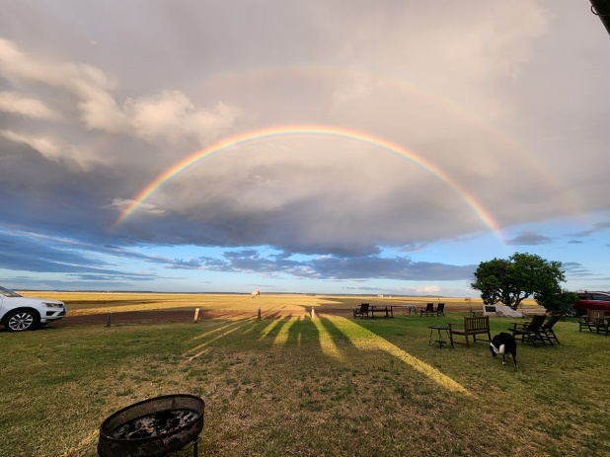Runways
* Outlandings
* Neighbours etc

### Aerodrome Access

Access to our aerodrome is via the front gate on (street name) using (key access/remote pin/keyless entry – include app requirements etc). On club days you will find this gate is already open, as the facility is being prepared for the days flying. (adjust where necessary).

Remember it is important that the club guidelines are also completed when accessing our facility, especially on weekends when we often have additional visitors. These include:

(Enter any club requirements i.e. registering intention to fly, booking gliders/instructors, daily briefing time. Remove if not required.)

Remember we always welcome you at the club earlier to assist with removing gliders from the hangar(s) and preparing for the day.

### Airfield Access

For the safety of all participants, when entering the airfield, you must always be aware of incoming and outgoing gliders and tow planes.

Only authorised vehicles are allowed on the airfield for retrieval purposes. Please do not drive on the airfield at any time unless authorised by the rostered Duty Officer.

### Parking

Parking is available on-site in front of the clubhouse/beside the hangar (add relevant details). Please ensure your vehicle does not obscure or create a hazard for other vehicles or pedestrians wishing to access the facility. No cars are to be parked on or near the airfield.

### Flying Days

Flying days for the club are usually on Saturdays, Sundays, and most Public Holidays (add relevant details). We are always weather-dependent so keep an eye out for our emails, and socials (add relevant details) to confirm flying and rostered duty instructors. There are times we are unable to fly but we still meet at the clubhouse regardless to work on odd jobs around the club and airfield. We welcome any help on those days to ensure the club and equipment are always ready to go.

### Club Days

(Insert club abbreviation) Club Days are designed to provide all members an opportunity to fly in a supportive environment regardless of their experience or skill level. We want you to get as much flying as possible to become more experienced and access further flying opportunities at a club, regional, or national level. We have a mix of pilots, students, instructors, and volunteers on our club days, so there is always plenty to do to be involved even when you are not flying.

Sometimes we have specific club events found here (insert hyperlink). Alternatively, we join other clubs in events/camps/regattas or just social activities as part of our gliding adventures. These activities are usually notified in our club newsletter/socials/emails (add relevant details).

## OUR CLUB FACILITIES

Our club is your club, and we want you to feel as comfortable as possible when attending our facilities, which include our clubhouse, toilet amenities, briefing room, airfield, and the club canteen/bar (add or delete as necessary).

### Clubrooms / Clubhouse

Our clubrooms/clubhouse amenities are available for members and visitors to enjoy on club days. There may be times when the clubrooms/clubhouse is available on other occasions such as courses, regattas, and maintenance days. Clubhouse amenities also include a kitchen area, lounge area, briefing room, toilet and shower facilities, viewing area, fire pit/BBQ area, and bunkhouse, (edit and add in any other relevant options).

Please be aware that any children accessing any of our club facilities must always be supervised by an adult.

### Noticeboard

Important club messages for members will be posted on the club notice board which is situated (insert location). It is important to always check the notice board before undertaking any activity to ensure members are up to date with any club, regional association, or Gliding Australia requirements.

### Food/Meals

When visiting the club for the day or weekend, you will need to bring your food and drink for the entirety of your stay. We have a kitchen area/access to a fridge where you can store your food for your trip. We ask that you clearly label your food/drinks with your name so there is no confusion on ownership.

We ask everyone to remove all items from the fridge after your visit to avoid any unnecessary wastage or odours in the clubhouse.

Our kitchen also has a stovetop, oven, and microwave available for use by our members. Please ensure you leave the kitchen clean and tidy for other members.

### Snacks

We have small amounts of snacks and drinks available in the clubhouse for purchase.

We work off an honour system so please place the suitable payment in the jar

provided.

OR

We have a small bar in the clubhouse where you can purchase non-alcoholic and alcoholic drinks, snacks, and chocolate. Payment can be made via EFTPOS; no cash payments are available.

### Alcohol

We like to have a good time, but you need to know our club is governed by several rules about consuming alcohol that we must adhere to.

Firstly, our club is overseen by Responsible Serving of Alcohol (RSA) regulations, therefore consumption of alcohol by minors is not permitted at any time.

No alcohol is to be consumed outside of the clubhouse, or social areas at any time.

CASA may, at any time, conduct an alcohol/drug test for anyone in an aerodrome testing area without notice, except for passengers. People may be randomly selected based solely on the fact that they are present in an aerodrome testing area.

Anyone performing, or available to perform, any of the specified ‘safety sensitive aviation activities’ (SSAA’s) must be alcohol-free. Anyone who is performing (or is available to perform) an ‘SSSA’, including sailplane repair and maintenance, ground handling of gliders, and servicing portable equipment e.g. parachutes, and oxygen cylinders, can be tested by CASA, whether those activities are conducted in an aerodrome testing area.

As safety is our priority, it is preferred that any activities involving alcohol are not commenced until the completion of the flying day.

### Toilet Amenities

You will find both female and male toilet and shower facilities on-site, with all-abilities access or a separate all-abilities toilet and shower.

These amenities are cleaned and maintained by club volunteers, so we appreciate you taking the time to keep them clean and tidy by putting rubbish in the bins supplied. Please let a committee member know if any areas of these amenities need attention or maintenance.

Please be mindful that both children and adults are utilising these amenities throughout the day, so please be respectful and provide appropriate supervision where necessary.



### Animals

For the safety of our participants and spectators’ animals are not allowed on site.

Or

Animals are allowed on site if they are restrained and are not allowed in grid or track areas at any times. Please be considerate of other members who may not be comfortable around animals and always clean up after your pet.

### Underage Driving

Any vehicles on (insert club abbreviation) property must be operated by a licensed motor vehicle driver. All Learners must be accompanied by a fully licensed driver.

### Facility Map

For your convenience, we have included a map of our facility to assist you in getting around. In addition to our clubhouse, we have club and private hangars, a workshop, bunkhouse,

(insert facility map)

### Communication

We want to be able to talk to you, we want you to talk with us and we want you to share how great gliding can be with all your friends and family.

We have several communication platforms that you can join, follow, or view. We want you to like and follow us, share, and tag our club and karting in general relevant posts and while you are there jump on Gliding Australia’s social media pages as well.

We want to see you and hear you but remember we need to respect our gliding community so don’t say or post anything that may be offensive to anyone in the club or to gliding in general.

### Communication Platforms

Our social media platforms are (add or delete as necessary):

|  |  |
| --- | --- |
|  | Insert Name of Account and Hashtags Here  #racingstartshere |
|  | Insert Name of Account and Hashtags Here  #racingstartshere |
|  | Insert Name of Account and Hashtags Here  #racingstartshere |
|  | Insert Name of Account and Hashtags Here  #racingstartshere |
|  | Insert Name of Account and Hashtags Here  #racingstartshere |





## VOLUNTEERING

***As we mentioned we cannot run our club without your help….***

We are aware everyone’s circumstances are different with work, family and competing activities/sports in today’s world. We do not want to add extra stress to busy lives, but we want you to know that your support of our club is always very appreciated. We hope to make our club a friendly, well run, and secure environment for our members and their families, so we offer a variety of roles, jobs, activities, or tasks that fit into your schedule.

We welcome any help, regardless of how often or the size of the task, and we are confident we can find something that matches your time and skills. Many hands make light work in running our club so please contact (add name and contact details or list some of the contacts for different volunteering spaces in your club) to express your interest and availability.

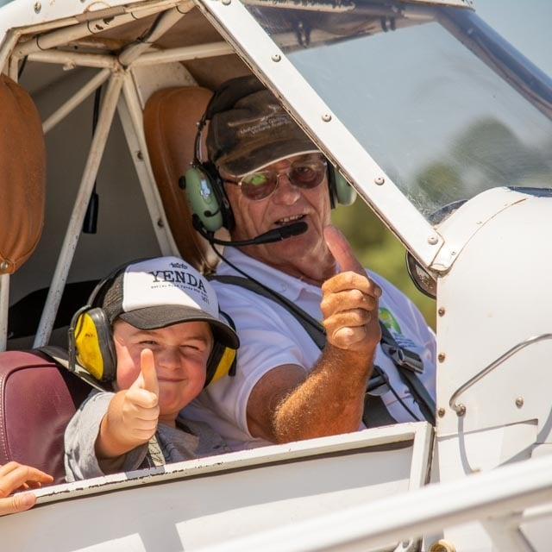

### Working With Children Checks

To be a volunteer within our sport, or any sport, you **MUST** have a Working with Children Check approved, in your State or Territory, if you are likely to come into contact with children. Good news is, as a volunteer, it is **FREE** to apply.

In most cases we need you to get this card before you start volunteering, so it’s a great idea to get in early and then let us know your card details when you receive it. Just search “Working with Children Card in (enter state)” and our state application portal should become available.

Don’t forget to let us know you are interested in assisting us, even before you get your card. We want to make volunteering as easy as possible for you, so this way we can start getting you ready with any information that can help you upskill or transition into a volunteering role for our club.

### Committee

As mentioned, our club is run by volunteers, both in and out of the sky. Legally our club must be run by a management committee/committee/board by our club rules. To help make this easier we have a committee induction kit and access to some webinar training available. This can be done at your convenience, to assist people in understanding the roles and responsibilities of a Committee Member or to learn new skills you may be interested in.

Even if you do not believe you have time to take on a complete role but have an interest in other areas of the club like social media, fundraising, grants, facility development, etc please let us know. We can always see what tasks we may have on hand or that are upcoming as your help would be greatly appreciated. If this space interests you, please contact (insert name and email/number).

### Trainers/Instructors

Our trainers and instructors are highly valued in the club and in all honestly gliding would not exist without the tuition they provide for new students and upskilling our members. We know this is not something you can do straight away but we would love to put it on your radar in the future. The first step of instructing is getting accredited to provide Air Experience Instruction/Flights and you can do this if you are over 16 years old and have completed 50 hours of flight time and 100 launches as a Pilot in Command.

To learn more about becoming an Instructor/Trainer, chat with the club's Chief Flying Instructor (CFI), who can give you more information about the Trainers pathway in gliding.

### Other roles

If we have not mentioned a role that may interest you or you have some expertise in certain areas that may assist the club, we want to hear from you. Please contact (insert name and email/number) so we can arrange a time to chat. We’d love to hear from you about how you might be able to make our club an even better place to be part of.

# WHAT TO EXPECT IN GLIDING

When know people come to gliding for different reasons. You may be interested in an aviation career, joining the Air Force, or just love the feeling of freedom within the clouds. Regardless of your reason for starting in gliding, we understand the rules that govern our sport can be a little overwhelming at first.

We have outlined a few points below to help you but remember, we will always have people at the club happy to help you settle into the gliding community who can also guide you on what needs to be done. Just ask us!

### Pilot Training

For some people, considering undertaking gliding training can be daunting. We want to assure you that Glider training in Australia follows a standardized, competency-based system and is delivered by experienced instructors who have undergone a qualification process delivered by Gliding Australia. This comprehensive program covers all aspects of gliding, from your first flight to achieving your Glider Pilot Certificate. This certification allows you to fly at gliding clubs across the country.

Training manuals for students can be found on the Gliding Australia website. These will assist with the theory that will accompany your practical training. We want you to remember this training is paced at a level that suits you, and everyone’s training time may look different depending on the time you have available.

### Manual of Standard Procedures (MOSP)

As you commence your training you will become familiar with the MOSP documents which are key documents for gliding operations in Australia. Published and maintained by Gliding Australia, they outline essential procedures and regulations for all gliding activities. Key areas covered include:

* Operational procedures
* Safety regulations
* Training standards
* Airworthiness requirements
* Competition rules

All gliding clubs and individual members must adhere to the MOSP guidelines. It serves as a crucial reference for pilots, instructors, and club administrators, ensuring safe and standardized operations throughout Australia's gliding community.

Your local club will also have local Standard Operating Procedures.

### Pilot Logbooks

As you begin your training, you'll need to purchase a glider pilot logbook. This essential document is where you'll record details of all your flights, including training and solo flights. Key points about logbooks:

* It's a legal document and an official record of your experience and currency.
* Each entry typically includes the date of flight, glider type and registration, launch method (e.g., winch, aerotow, self-launch), and flight duration.
* It helps track your progress, including total flight hours, number of launches, and types of flights (local, cross-country, competition).

### Daily Briefings

Many clubs conduct morning briefings before the day's flying activities to assist pilots with their flying activities for the day. These sessions typically cover:

* Aircraft allocation
* Weather conditions
* Local airfield conditions
* Important announcements
* Organisation of training flights for the day

Attending these briefings is crucial for staying informed and prepared for your flying activities so ensure you arrive at the club early enough to attend these information briefings.

### Appropriate Clothing

Gliding is an outdoor sport and being sun-smart is important. We recommend:

* Sun-smart clothing: Long-sleeved shirts and long pants
* A sun smart hat (bucket hats are preferred for better in-flight visibility)
* Sunscreen
* Water bottle or hydration pack to take in the aircraft

Your local club may sell appropriate gliding attire.

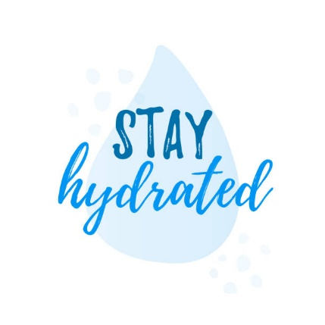



# EVENTS

### Club Championship Trophies/Awards

We told you club events are important to us. So, even though we believe every member is a winner at our club, we still like to acknowledge those Club Members who have excelled at our club events.

Explain your eligibility, process, and awards here.

Trophies and awards are presented at the end-of-year presentation dinner/afternoon/other, and we encourage you and your families to attend these celebrations.

### Social

Our club is not just about gliding …we have just as much fun on the ground as we do in the sky! Keep an eye out for our social events held throughout the year which range from after-event BBQ’s, Working Bees, Family activities, and Dinners (add or delete as necessary).

If you are interested in assisting with organising any of our social events or have any ideas for new social events, let us know as we always welcome any volunteering assistance.

### State and National Events

As you become more skilled and confident in gliding you may be interested in some of the state and national championships which are held annually. We will make sure we communicate to all our members when these event registrations are open.

If you want to know more about how these events work or how experienced you need to be, please reach out to any of the committee members, CFI, or instructors who will be more than happy to answer any questions you may have.

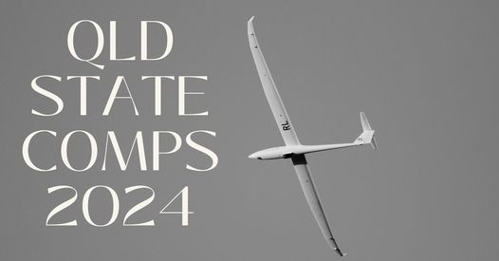In the meantime, these events always require volunteers to assist on the ground so even if you do not want to compete you can still be part of the action.

# INTEGRITY

### Safeguarding Young People

Our club has a zero-tolerance policy around child and young person abuse and neglect in any form. We are committed to keeping young people safe in and out of the sky. So, we need your help to do this!

As a valued member of our gliding community, you play a crucial role in protecting young people in our sport. Legally you MUST know what you should do if you come across, suspect, or feel uncomfortable with a situation a young person may be in or may potentially become involved in. This includes:

A more detailed policy in dealing with children can be found on the [GA Website](https://glidingaustralia.org/integrity/) or you can contact our club Member Protection Information Officer/Child Safety Contact on the following (insert club details).

Finally, because we want our club to be young people safe, we would like you to read through the safe and unsafe behaviours in gliding poster on the following page.

